IAIC2023-PXXX
Your Paper's Title Starts Here: Please Center use VistaSansMed (Century) 18
FULL Name First Author¹, ª, FULL Name Second Author²,^{b} and Others³,^{c}
^{1,a} Organize of first author, including country; ^{2,b} Organize of second author, including country; ^{3,c} List all organize in the same way
ª email, ^{b} email, ^{c} email
Abstract
This document explains and demonstrates how to prepare your camera-ready manuscript for International Agriculture Innovation Conference (IAIC). The best is to read these instructions and follow the outline of this text. The text area for your manuscript must be 17 cm wide and 25 cm high (6.7 and 9.8 inches, resp.). Do not place any text outside this area. Use good quality, white paper of approximately 21 x 29 cm or 8 x 11 inches (please do not change the document setting from A4 to letter). All manuscripts must be in English. Please keep a second copy of your manuscript in your office (just in case anything gets lost in the mail). When receiving the manuscript, we assume that the corresponding authors grant us the copyright to use the manuscript for the book or journal or porceeding in question. Should authors use tables or figures from other Publications, they must ask the corresponding publishers to grant them the right to publish this material in their paper.
The abstract should be a summary of your presentation and included the keywords. Please avoid scientific or engineering symbols, acronyms and bullets. The submission must be in English and it should be typed exactly-spaced at 12 in 11-point type Cambria in Microsoft Word file (*.doc/*docx). Use italic for emphasizing a word or phrase. Do not use boldface typing or capital letters except for section headings (cf. remarks on section headings, below).
Keywords: List the keywords covered in your paper. These keywords will also be used by the publisher to produce a keyword index. Single, Paragraph, Summarizes, words indentation (maximum 6 words)
Introduction (Cambria 14)
All manuscripts must be in English. Please keep a second copy of your manuscript in your office (just in case anything gets lost in the mail). When receiving the manuscript, we assume that the corresponding authors grant us the copyright to use the manuscript for the book or journal in question. Should authors use tables or figures from other Publications, they must ask the corresponding publishers to grant them the right to publish this material in their paper.
The submission must be in English and it should be typed exactly-spaced at 12 in 11-point type Cambria in Microsoft Word file (*.doc/*docx). Full manuscript at least 4 pages, including abstract, references, tables / charts/ pictures and keywords.
Organization of the Text (Cambria 14)
All manuscripts must be in English. Please keep a second copy of your manuscript in your office (just in case anything gets lost in the mail). When receiving the manuscript, we assume that the corresponding authors grant us the copyright to use the manuscript for the book or journal in question. Should authors use tables or figures from other Publications, they must ask the corresponding publishers to grant them the right to publish this material in their paper.
The submission must be in English and it should be typed exactly-spaced at 12 in 11-point type Cambria in Microsoft Word file (*.doc/*docx). Full manuscript at least 4 pages, including abstract, references, tables / charts/ pictures and keywords.
Methodology (Cambria 14)
Section Headings (Cambria 13)
The section headings are in boldface capital and lowercase letters. Second level headings are typed as part of the succeeding paragraph (like the subsection heading of this paragraph)
Formula and Equation (Cambria 13)
In this sample, the following equations are presented as illustration

𝑦 = 𝛽₀ + 𝛽₁𝑥₁ + 𝛽₂𝑥₂ + ⋯ + 𝛽_{𝑛}𝑥_{𝑛} | (1)

and nonlinear regression model or the general form of the Cobb-Douglas function with multivariable is:

$y=Ax_{1}^{α_{1}}x_{2}^{α_{2}}x_{3}^{α_{3}}⋯x_{n}^{α_{n}}, (A, α_{i}<1, \left[i=\overline{1,n}\right]-тогтмол тоонууд)$$y=Ax_{1}^{α_{1}}x_{2}^{α_{2}}x_{3}^{α_{3}}⋯x_{n}^{α_{n}}, (A, α_{i}<1, \left[i=\overline{1,n}\right]-constant)$ | (2)

where $y$- response (dependent) variable, $x_{i} (i=1,2,…,n)$- explanatory (independent) variables.
If we take a natural logarithm from both sides of this equation, we have the following linear form:

$y=Ax_{1}^{α_{1}}x_{2}^{α_{2}}x_{3}^{α_{3}}⋯x_{n}^{α_{n}}, (A, α_{i}<1, \left[i=\overline{1,n}\right]-тогтмол тоонууд)$$\ln{y}=\ln{A}+α_{1}{\ln{x}}_{1}+α_{2}{\ln{x}}_{2}+…+α_{n}{\ln{x}}_{n}$ | (3)
where $α_{i} (i=1,2,…,n)$ indicate the sensitivities of the variables. Sensitivity refers to the percentage change in the variable $i$ when a variable is changed by 1 percent [6].
In general, the model can be written as follows.

$$MSAVI=f\left(NDVI,LST,AT, WS, P\right)$$ | (4)

All manuscripts must be in English. Please keep a second copy of your manuscript in your office (just in case anything gets lost in the mail). When receiving the manuscript, we assume that the corresponding authors grant us the copyright to use the manuscript for the book or journal in question. Should authors use tables or figures from other Publications, they must ask the corresponding publishers to grant them the right to publish this material in their paper.
Sample A (Cambria 12)
All manuscripts must be in English. Please keep a second copy of your manuscript in your office (just in case anything gets lost in the mail). When receiving the manuscript, we assume that the corresponding authors grant us the copyright to use the manuscript for the book or journal in question. Should authors use tables or figures from other Publications, they must ask the corresponding publishers to grant them the right to publish this material in their paper.
Sample B (Cambria 12)
All manuscripts must be in English. Please keep a second copy of your manuscript in your office (just in case anything gets lost in the mail). When receiving the manuscript, we assume that the corresponding authors grant us the copyright to use the manuscript for the book or journal in question. Should authors use tables or figures from other Publications, they must ask the corresponding publishers to grant them the right to publish this material in their paper.
Figures, Tables and Picture (Cambria 13)
Figures and tables should be placed in suitable spaces and avoid placing them in the middle of columns. The tables should also be numbered like Table 1, 2, 3…etc and same as figure. Figure captions should be centered below the figures; table captions should be centered above. Figures should be supplied in either vector art formats (Illustrator, EPS, WMF, FreeHand, CorelDraw, PowerPoint, Excel, etc.) or bitmap formats (Photoshop, TIFF, GIF, JPEG, etc.). Bitmap
images should be of 300 dpi resolution at least. Pictures should be supplied electronic image file, original files of 300 dpi or more and should be indicated the file name and ordinal number of picture.
Table 1. The MODIS satellite used data
Terra/MODIS | Product name | Spatial resolution(m) | Temporal resolution(days)
Product code
MOD09A1.006 | RED | 500 | 8
MOD09A1.006 | NIR | 500 | 8
MOD11A2.006 | LST | 1000 | 8
MOD13Q1.006 | NDVI | 250 | 16

Figures and tables should be placed in suitable spaces and avoid placing them in the middle of columns. The tables should also be numbered like Table 1, 2, 3…etc and same as figure. Figure captions should be centered below the figures; table captions should be centered above. Figures should be supplied in either vector art formats (Illustrator, EPS, WMF, FreeHand, CorelDraw, PowerPoint, Excel, etc.) or bitmap formats (Photoshop, TIFF, GIF, JPEG, etc.). Bitmap images should be of 300 dpi resolution at least. Pictures should be supplied electronic image file, original files of 300 dpi or more and should be indicated the file name and ordinal number of picture.

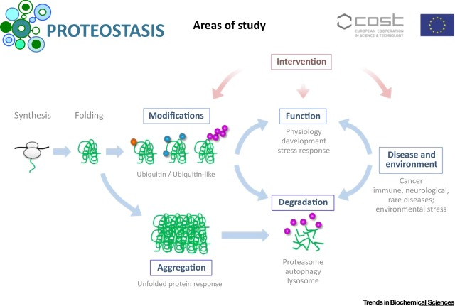

Figure 1. Study area
Figures and tables should be placed in suitable spaces and avoid placing them in the middle of columns. The tables should also be numbered like Table 1, 2, 3…etc and same as figure. Figure captions should be centered below the figures; table captions should be centered above. Figures should be supplied in either vector art formats (Illustrator, EPS, WMF, FreeHand, CorelDraw, PowerPoint, Excel, etc.) or bitmap formats (Photoshop, TIFF, GIF, JPEG, etc.). Bitmap images should be of 300 dpi resolution at least. Pictures should be supplied electronic image file, original files of 300 dpi or more and should be indicated the file name and ordinal number of picture.

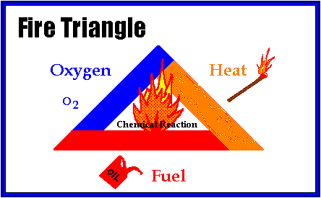
Figure 2. Fire triangle
References (CAMBRIA 14)
References are cited in the text just by square brackets [1]. (If square brackets are not available, slashes may be used instead, e.g. /2/.) Two or more references at a time may be put in one set of brackets [3,4]. The references are to be numbered in the order in which they are cited in the text and are to be listed at the end of the contribution under a heading References, see our example below.
[1] Author, A, Author, B and Author, C,: Mater. Sci. Forum Vol. 83-87 (1992), p. 119
[2] Author, A: High Efficiency Silicon Solar Cells (Trans Tech Publications, Switzerland 1987).
[3] Y. Mishing, in: Diffusion Processes in Advanced Technological Materials, edtied by D. Gupta Noyes Publications/William Andrew Publising, Norwich, NY (2004), in press.
[4] G. Henkelman, G.Johannesson and H. Jónsson, in: Theoretical Methods in Condencsed Phase Chemistry, edited by S.D. Schwartz, volume 5 of Progress in Theoretical Chemistry and Physics, chapter, 10, Kluwer Academic Publishers (2000).
[5] Author, A. (date). Title of document [Format description]. Retrieved from http://xxxxxxxxx
[6] Author, A. (date). Title of chapter. In E. Editor (Ed.), Title of book (pp. xx–xx). Retrieved from http://xxxxxxxxx
[7] Author, A. A. [Screen name]. (year, month day). Title of video [Video file]. Retrieved from http://xxxxxxxxx
More information about reference, please clice here.

Authors’ Background
Your Name | Title* | Research Field | Personal website
*This form helps us to understand your paper better, the form itself will not be published.
*Title can be chosen from: master student, Phd candidate, assistant professor, lecture, senior lecture, associate professor, full professor

