IAIC2024-CSXXX
Your Paper's Title Starts Here: Please Center use VistaSansMed (Century) 18
FULL Name First Author¹, ª, FULL Name Second Author²,^{b} and Others³,^{c}
^{1,a} Organization of first author, including country; ^{2,b} Organization of second author, including country; ^{3,c} List all organizations authors are affiliated with in the same way
ª email, ^{b} email, ^{c} email
Abstract
This document explains and demonstrates how to prepare your camera-ready manuscript for International Agriculture Innovation Conference (IAIC). The best is to read these instructions and follow the outline of this text. The text area for your manuscript must be 17 cm wide and 25 cm high (6.7 and 9.8 inches, resp.). Do not place any text outside this area. Select page size of approximately 21 x 29 cm or 8 x 11 inches (please do not change the document setting from A4 to letter). All manuscripts must be in English. The onus is on the author/s to ensure that the manuscript is received by the conference secretariat. When receiving the manuscript, we assume that the corresponding authors grant us the copyright to use the manuscript for e-book, hournal or conference proceeding. Should authors use tables or figures from other Publications, they must ask the corresponding publishers to grant them the right to publish this material in their manuscript.
The abstract should be a summary of your presentation and include the keywords. Please avoid scientific or engineering symbols, acronyms and bullets. Use 11-point type Cambria and submit in Microsoft Word file (*.doc/*docx). Use italic for emphasizing a word or phrase. Do not use boldface typing or capital letters except for section headings (cf. remarks on section headings, below).
Keywords: List the keywords covered in your paper. These keywords will also be used by the publisher to produce a keyword index. Single, Paragraph, Summarizes, words indentation (maximum 6 words)
Introduction (Cambria 14)
In the introduction you should identify the key problem/s and issues in the case study. State the problem/s succinctly providing how your came to identify the problem/s; i.e. your analysis. Provide a summary of the rest of the case.
Sample text: All manuscripts must be in English. Please keep a second copy of your manuscript in your office (just in case anything gets lost in the mail). When receiving the manuscript, we assume that the corresponding authors grant us the copyright to use the manuscript for the book or journal in question. Should authors use tables or figures from other Publications, they must ask the corresponding publishers to grant them the right to publish this material in their paper.
cONText (Cambria 14)
In this section, you provide background information, relevant facts and the most important issues. You relate the relevant state of the industry, process, crop or technology, demonstrating that you have understood the problems in this case study and are offering a possible solution or alternative approach.
Sample Text: The submission must be in English and it should be typed exactly-spaced at 12 in 11-point type Cambria in Microsoft Word file (*.doc/*docx). Full manuscript at least 4 pages, including abstract, references, tables / charts/ pictures and keywords.
aLTERNATIVES (Cambria 14)
Section Headings (Cambria 13)
In this section, you outline the possible alternatives that exist or are being explored. Explain your selection from among the alternatives, providing justification for the rejection of the other alternatives.
The section headings are in boldface capital and lowercase letters. Second level headings are typed as part of the succeeding paragraph (like the subsection heading of this paragraph)
All manuscripts must be in English. Please keep a second copy of your manuscript in your office (just in case anything gets lost in the mail). When receiving the manuscript, we assume that the corresponding authors grant us the copyright to use the manuscript for the book or journal in question. Should authors use tables or figures from other Publications, they must ask the corresponding publishers to grant them the right to publish this material in their paper.
Alterative A (Cambria 12)
All manuscripts must be in English. Please keep a second copy of your manuscript in your office (just in case anything gets lost in the mail). When receiving the manuscript, we assume that the corresponding authors grant us the copyright to use the manuscript for the book or journal in question. Should authors use tables or figures from other Publications, they must ask the corresponding publishers to grant them the right to publish this material in their paper.
Alternative B (Cambria 12)
All manuscripts must be in English. Please keep a second copy of your manuscript in your office (just in case anything gets lost in the mail).
Figures, Tables and Picture (Cambria 13)
Figures and tables should be placed in suitable spaces and avoid placing them in the middle of columns. The tables should also be numbered like Table 1, 2, 3…etc and same as figure. Figure captions should be centered below the figures; table captions should be centered above. Figures should be supplied in either vector art formats (Illustrator, EPS, WMF, FreeHand, CorelDraw, PowerPoint, Excel, etc.) or bitmap formats (Photoshop, TIFF, GIF, JPEG, etc.). Bitmap images should be of 300 dpi resolution at least. Pictures should be supplied electronic image file, original files of 300 dpi or more and should be indicated the file name and ordinal number of picture.
Table 1. The MODIS satellite used data
Terra/MODIS | Product name | Spatial resolution(m) | Temporal resolution(days)
Product code
MOD09A1.006 | RED | 500 | 8
MOD09A1.006 | NIR | 500 | 8
MOD11A2.006 | LST | 1000 | 8
MOD13Q1.006 | NDVI | 250 | 16

Figures and tables should be placed in suitable spaces and avoid placing them in the middle of columns. The tables should also be numbered like Table 1, 2, 3…etc and same as figure. Figure captions should be centered below the figures; table captions should be centered above. Figures should be supplied in either vector art formats (Illustrator, EPS, WMF, FreeHand, CorelDraw, PowerPoint, Excel, etc.) or bitmap formats (Photoshop, TIFF, GIF, JPEG, etc.). Bitmap images should be of 300 dpi resolution at least. Pictures should be supplied electronic image file, original files of 300 dpi or more and should be indicated the file name and ordinal number of picture.

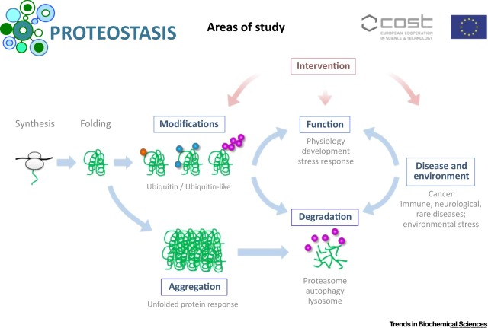

Figure 1. Study area
Figures and tables should be placed in suitable spaces and avoid placing them in the middle of columns. …

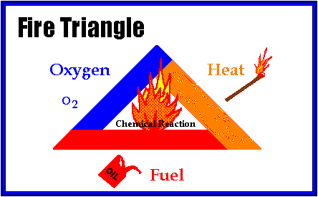
Figure 2. Fire triangle
PROPOSED SOLUTION (CAMBRIA 14)
Describe what was finally done/adopted in the case study. Explain why this solution was chosen. Report the outcomes of the approach supporting with evidence either empirical from the case experience, other research or anecdotal evidence. Discuss the benefits of the adopted solution/approach against other prior approaches.

RECOMMENDATIONS(CAMBRIA 14)
In this section, you should recommend how others can adopt the approach/process adopted in the case. You should suggest specific strategies for implementing you solution. If the situation in the case is not completely resolved, recommend further steps that might be needed.

References (CAMBRIA 14)
References are cited in the text just by square brackets [1]. (If square brackets are not available, slashes may be used instead, e.g. /2/.) Two or more references at a time may be put in one set of brackets [3,4]. The references are to be numbered in the order in which they are cited in the text and are to be listed at the end of the contribution under a heading References, see our example below.
[1] Author, A, Author, B and Author, C,: Mater. Sci. Forum Vol. 83-87 (1992), p. 119
[2] Author, A: High Efficiency Silicon Solar Cells (Trans Tech Publications, Switzerland 1987).
[3] Y. Mishing, in: Diffusion Processes in Advanced Technological Materials, edtied by D. Gupta Noyes Publications/William Andrew Publising, Norwich, NY (2004), in press.
[4] G. Henkelman, G.Johannesson and H. Jónsson, in: Theoretical Methods in Condencsed Phase Chemistry, edited by S.D. Schwartz, volume 5 of Progress in Theoretical Chemistry and Physics, chapter, 10, Kluwer Academic Publishers (2000).
[5] Author, A. (date). Title of document [Format description]. Retrieved from http://xxxxxxxxx
[6] Author, A. (date). Title of chapter. In E. Editor (Ed.), Title of book (pp. xx–xx). Retrieved from http://xxxxxxxxx
[7] Author, A. A. [Screen name]. (year, month day). Title of video [Video file]. Retrieved from http://xxxxxxxxx
More information about reference, please clice here.

Authors’ Background
Your Name | Title* | Research Field | Personal website
*This form helps us to understand your paper better, the form itself will not be published.
*Title can be chosen from: master student, Phd candidate, assistant professor, lecture, senior lecture, associate professor, full professor

